GRACE’s Safeguarding Training is designed to give any and all adults in the church skills to contribute to safety in the community. The training will be hosted by The Lighthouse Child Advocacy Center for the churches of Wetzel and Tyler Counties. Surrounding area churches are also welcome.

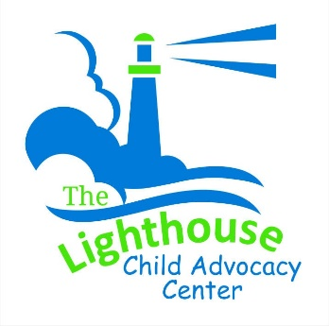
The training will focus on the necessary tools to recognize, prevent, and respond to abuse in a godly way, as well as care for survivors. This training will address common forms of abuse with a particular focus on abuse within a church setting. The training is PowerPoint-based and interactive throughout.

This in-person training will cover the follow specific topics:

1. Facing the Reality of Abuse in the Church
• How the Bible Speaks to Abuse
• Jesus’s Teaching and Basic Abuse Dynamics
• The Role All Play in a Safe Community
• Definitions and Prevalence of Abuse
• Interactive Scenario: Recognizing Common Abuse Dynamics

2. Responding to the Impact of Abuse
• Common Impacts of Abuse
• Introduction to Trauma
• Becoming a Trauma-Informed Community
• Practical Skills When Caring for Survivors

3. Understanding Offenders and Their Tactics
• Offender Dynamics
• Understanding Grooming Tactics
Scan to Register
• Interactive Exercise: Recognizing Grooming Behavior
• Recognizing DARVO as an Offender Tactic
• Accountability and Forgiveness

4. Your Role in Prevention and Response
• Your Role in Upholding Safe Boundaries
• Responding to Concerning Behavior
• Owning Your Policy as a Community
• Response to Child Abuse: Basics and Q&A
• How to Recognize Child Abuse: Common Response Situations
• Response to Adult Abuse

April 13, 2024 from 9a.m. to 1p.m.
at First Church of God, 255 Russell Avenue, New Martinsville

