# A P R I L - J U N E 2 0 2 5

w [ww.thelighthousecac.org](http://thelighthousecac.org/)



**THE LIGHTHOUSE CHILD ADVOCACY CENTER**

Serving: Wetzel and Tyler Counties

**What’s Inside:**

**The Lighthouse CAC Updates Community Involvement Training Opportunities Mental Health Moment**

**Our Team and Board of Directors Contact Us**

**A Message from the Executive Director:**

Dear Friends,

As we wrap up another super busy and impactful quarter, I want to thank our community, partners, and supporters for standing with us in our mission to bring hope and healing to child survivors of abuse. This spring, we focused on outreach, awareness, and growth—culminating in a successful Child Abuse Prevention Month and exciting steps forward in our mental health expansion. Every child we serve reminds us why this work matters.

Thank you for helping us be a light in their darkest moments.

With gratitude, Susan Scharf Executive Director

Lighthouse Child Advocacy Center

**Our Work By the #s**

Since January 2025, The Lighthouse Child Advocacy Center has seen a total of **54 new children** following suspected abuse or neglect. Our services included:

57 developmentally appropriate, child-friendly, fact-finding forensic interviews

200 trauma-focused therapy sessions 37 referrals for mental health services

146 instances of advocacy services provided to children and families

1,013 children provided body safety education

# A P R I L - J U N E 2 0 2 5

w [ww.thelighthousecac.org](https://thelighthousecac.org/)



**THE LIGHTHOUSE CHILD ADVOCACY CENTER**

Updates from the CAC

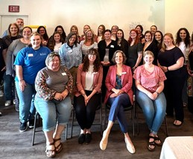

**What is a CAC?**

**The Lighthouse Child Advocacy Center (CAC) is a child-friendly, safe facility where child protection, criminal justice, and treatment professionals work together to investigate abuse, hold offenders accountable, and help children heal.**

**Without a CAC, child victims of abuse can be taken from agency to agency and endure multiple interviews, which creates additional trauma and wastes valuable resources.**

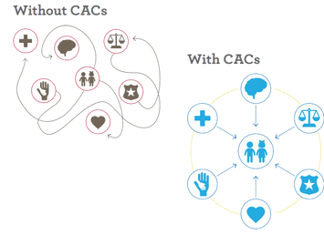

**NASW WV Spring Social Work Conference**

Training Hosted by WVCAN

**Responding to Suicidality at the CAC**

Becky and Brittany attended the *Responding to Suicidality at the CAC* training hosted by WVCAN in Charleston, WV. This training was presented by Southern Regional CAC and provided crucial information on best practices, language and policies for responding to suicidality.

Both of The Lighthouse CAC therapists Jacqueline and Lindsey attended the two day NASW WV Spring Social Work Conference. They had a great time networking and engaging with other social workers and learning valuable information to use while providing trauma-focused therapy to our clients. The mental health expansion of the CAC is nearing the 1 year mark and we are excited for the future growth and service to our clients.

# A P R I L - J U N E 2 0 2 5

w [ww.thelighthousecac.org](https://thelighthousecac.org/)

**THE LIGHTHOUSE CHILD ADVOCACY CENTER**

Community Involvement



**The Lighthouse CAC is Hosting a Food Truck Fundraier**

Mark your calendars and join us in July for a delicious lineup of food trucks supporting The Lighthouse CAC — where every bite makes a difference! Your lunch plans just got better AND more meaningful. Come hungry and support a great cause. Each truck brings something special to the table — and your support helps us continue providing critical services and advocacy for kids in Wetzel and Tyler Counties.

**Where your donation goes:**

Forensic Interviews Compassionate Advocacy Trauma-informed Therapy

Essential Resources for Families

Community Education Professional Training Advocacy and Prevention

**Training Opportunities**

**National Children’s Advocacy Center Virtual Training Center**

[https://ncacvtc.org](https://ncacvtc.org/)

**Southern Regional Children’s Advocacy Center**

<https://www.srcac.org/training>

**Midwest Regional Children’s Advocacy Center**

<https://www.mrcac.org/edunet-webinars>

**Making a Difference: Mandate to Report**

Rebecca Bailey, Outreach Advocate is trained facilitator, contact CAC to schedule

**A P R I L - J U N E 2 0 2 5**

w [ww.thelighthousecac.org](https://thelighthousecac.org/)

**THE LIGHTHOUSE CHILD ADVOCACY CENTER**

Community Involvement

**Mental Health Moment**

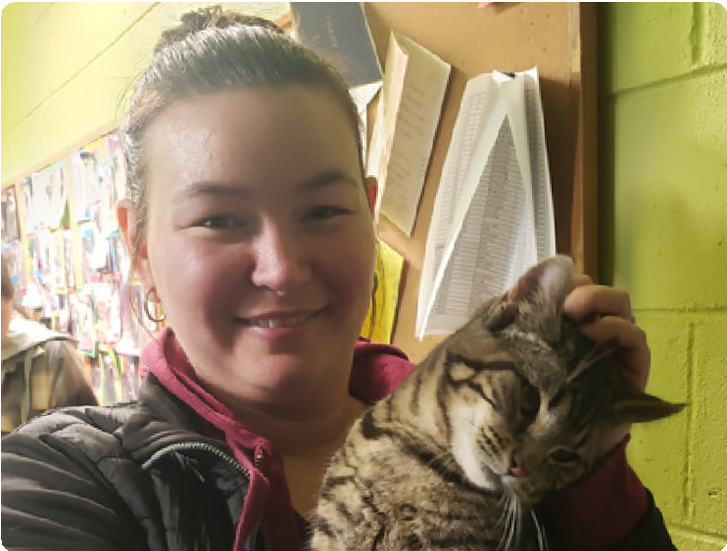

**Staff Day Outing**

The CAC team took a much-needed Staff Day to relax, recharge, and reconnect in April. We try to do this 3–4 times a year, and we always decide together where we’ll go and how we’ll spend the day.

This time, our team’s heart led us to some furry friends We had the absolute pleasure of visiting the [Olive Branch](https://www.facebook.com/profile.php?id=100064895493712&__cft__%5B0%5D=AZWqVVIAtZjTWz-AkTVC6k2dj7XjaiLJ55l3N7c8t2Uap41WgzU1Ll-KKvaHcqF1HHI3PQQYr9YlLp6cq-o0dsKGt0152WjuAYdY6uK-6ERxLMgLGRospudkm7J5t8LxwKLifOWt7ECpyrliyCUfBe-7RMfSBVxk4D8nt4MCBOQZoeEKli8es1qhb1r_xqe9SIZcTY-lL0TL54ZY1vC16nQx&__tn__=-%5DK-R) [Animal Rescue & Refuge, Inc.](https://www.facebook.com/profile.php?id=100064895493712&__cft__%5B0%5D=AZWqVVIAtZjTWz-AkTVC6k2dj7XjaiLJ55l3N7c8t2Uap41WgzU1Ll-KKvaHcqF1HHI3PQQYr9YlLp6cq-o0dsKGt0152WjuAYdY6uK-6ERxLMgLGRospudkm7J5t8LxwKLifOWt7ECpyrliyCUfBe-7RMfSBVxk4D8nt4MCBOQZoeEKli8es1qhb1r_xqe9SIZcTY-lL0TL54ZY1vC16nQx&__tn__=-%5DK-R) in Tyler County and the [Wetzel County Animal](https://www.facebook.com/profile.php?id=100064934462333&__cft__%5B0%5D=AZWqVVIAtZjTWz-AkTVC6k2dj7XjaiLJ55l3N7c8t2Uap41WgzU1Ll-KKvaHcqF1HHI3PQQYr9YlLp6cq-o0dsKGt0152WjuAYdY6uK-6ERxLMgLGRospudkm7J5t8LxwKLifOWt7ECpyrliyCUfBe-7RMfSBVxk4D8nt4MCBOQZoeEKli8es1qhb1r_xqe9SIZcTY-lL0TL54ZY1vC16nQx&__tn__=-%5DK-R) [Shelter](https://www.facebook.com/profile.php?id=100064934462333&__cft__%5B0%5D=AZWqVVIAtZjTWz-AkTVC6k2dj7XjaiLJ55l3N7c8t2Uap41WgzU1Ll-KKvaHcqF1HHI3PQQYr9YlLp6cq-o0dsKGt0152WjuAYdY6uK-6ERxLMgLGRospudkm7J5t8LxwKLifOWt7ECpyrliyCUfBe-7RMfSBVxk4D8nt4MCBOQZoeEKli8es1qhb1r_xqe9SIZcTY-lL0TL54ZY1vC16nQx&__tn__=-%5DK-R) — and wow, what a great experience!

A good time was had by all (humans AND

animals alike)!



**April Sucessful Child Abuse Awareness Month**

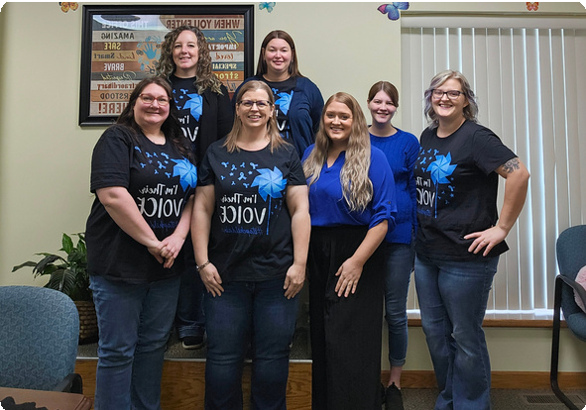 

During the month of April, The Lighthouse CAC placed pinwheels at 16 locations throughout Wetzel and Tyler Counties. We also had our 3rd annual High 5 Drive Fundraiser. We raised $853.32 this year! Thank you to the following donation sites for collecting money on our behalf :Union Bank Sistersville & Middlebourne, Bayer Heritage Federal Credit Union New Martinsville locations, Minna’s Main Street Salon. We are so grateful for the support from our community.



**A P R I L - J U N E 2 0 2 5**

w [ww.thelighthousecac.org](https://thelighthousecac.org/)

**THE LIGHTHOUSE CHILD ADVOCACY CENTER**

Serving: Wetzel and Tyler Counties

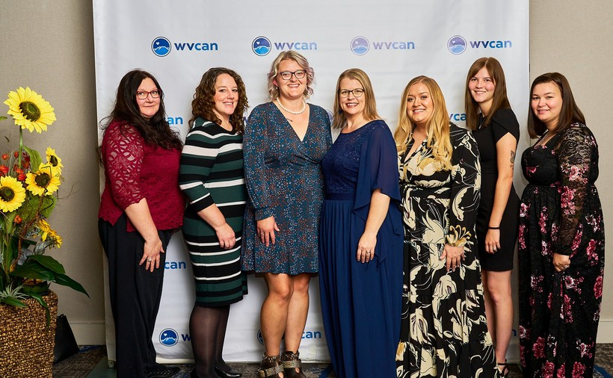

**Board of Directors**

**Danielle Ice- Davis**, Board President **Linda Leasure**, Board Vice-President **Marilyn Stout**, Board Secretary **Tammy Waggoner**, Board Treasurer **Katrina Byers**, Board Member

**Joel Davis**, Board Member

Contact Us

**Our Team**

**Susan Scharf**

Executive Director

**Kelsey Loy**

CAC Program Director

**Rebecca Bailey**

Outreach Advocate

**Breauna Knight**

Family Advocate

**Jacqueline Watkins MSW, LGSW**

Supervisory Therapist

**Lindsey Lewis MSW, LGSW**

Therapist

**Brittany Loub**

Administrative Assistant

By mail:

261 Monroe Ave.

New Martinsville, WV 26155

By email: [wetzel_tylercac@yahoo.com](mailto:wetzel_tylercac@yahoo.com)

By phone:

CAC: 304-398-2311

MH: 304-398-2313

Vist Our Website: [thelighthousecac.org](https://thelighthousecac.org/)

Follow us on Facebook: [@thelighthousecac](https://www.facebook.com/thelighthousecac)



## To Report Suspected Child Abuse or Neglect in WV:

**Call Centralized Intake: 1-800-352-6513 If an emergency: 911**